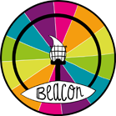 | BARNARDO’S  BEACON PROJECT  Training Request Form | 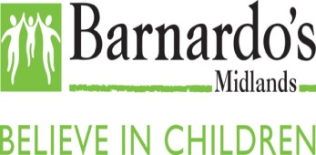

The Beacon Project Training is designed to help professionals build knowledge and understanding when supporting children/young people affected by “child sexual abuse”. For clarity:

Child Sexual Abuse (CSA) involves forcing or persuading a child or young person to take part in sexual activities, whether or not the child is aware of what is happening.
This includes acts that involve physical contact such as assault by penetration,
non-penetrative acts (eg. masturbation, kissing, rubbing and touching).

It also includes non-contact: involving children in looking at (or making) sexual images, watching sexual acts, encouraging children to behave in sexually inappropriate ways,
grooming a child (including via the internet).

All training and consultation that we offer professionals is free of charge and is centred on being trauma informed and young person centred.

- Organisation details

Contact name:

Agency/Organisation :

Organisation Address:

Contact telephone number :

Contact email address:

- Training request

What do you want from the training session:

Who will be in attendance (roles and responsibilities) /how many :

What platform would you like to use:

When do you want the training:

How long would you like the training to be:

Prior training/knowledge or experience of working in CSA:

- How did you hear about us
Online Search Recommendation Signposting Meeting Other

If other please specify…………………………………………………………………….

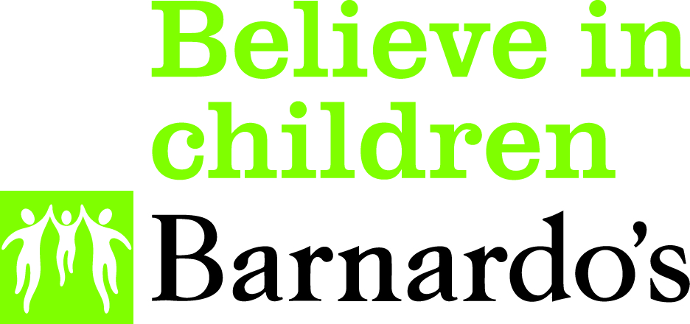

PLEASE RETURN THE COMPLETED FORM TO:

Beacon Project, Barnardo’s Black Country Roots, Blantyre House,
4 Barrack Lane, Halesowen, B63 2UX

If you have any questions regarding any section of this form, please contact us on
01384 411722

Website: www.barnardosbeacon.org.uk
Email: barnardosbeacon@barnardos.org.uk

What happens next?

- Returned and completed enquiry forms will be received by the Barnardos Beacon Team; forms received via email will receive an automated reply
- Your enquiry will be reviewed and discussed at a weekly triage meetings
- The Beacon team will aim to reply to your enquiry within 7 working days from receipt

