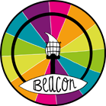 | BARNARDO’S  BEACON  CHILDREN AND YOUNG PERSONS ENQUIRY FORM | 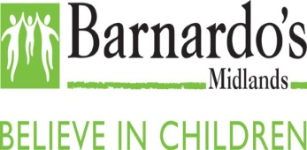
If you are under the age of 19 and living with the effects of sexual abuse and thinking about seeking or needing support then Beacon is a project designed to help you. The Beacon Project covers all of these areas: Birmingham, Coventry, Dudley, Herefordshire, Sandwell, Staffordshire, Stoke-on-Trent, Shropshire, Telford and Wrekin, Walsall, Warwickshire, Wolverhampton, Worcestershire

If you would like to access our service please complete this Enquiry form; if you need any help to complete the form please ask a trusted adult to support you or contact us on 01384 411722

- Your Details

First Name: Surname:

Date of Birth: Age:

Gender Identity: First/spoken Language:

Address including postcode:

Email Address:

Contact/Mobile Telephone Number:

*Emergency Contact Name and Telephone Number:

*This is the telephone number of someone that you trust i.e. your parent/carer, a teacher etc.

What is your preferred method of contact:-

Text Phone Email Letter

Is it ok for us to leave a voicemail message on your mobile? Yes No

- Your information – please answer the following questions as best as you can so we are able to access the right support for you

Is this the first time you have told anyone about your abuse? Yes No

If No who have you told?

Do you feel Safe? Yes No
Please note if you are in immediate danger and require an urgent reply please speak to a trusted adult or call ChildLine on 0800 1111

When did the incident of sexual abuse happen (Date)?

Are you in contact with the perpetrator of sexual abuse? Yes No

Are the police investigating the incident(s) of sexual abuse? Yes No

If yes when were the allegations reported to the police (Date)?

Do you have a Social Worker? Yes No

If yes please provide your Social Workers name and telephone number:-

Name:

Telephone Number:

- Your Support Network

Do you attend School/college? Yes No

If yes please provide the name of your school/college:

Do you have one trusted adult in your life? Yes No

Are you receiving any therapeutic support i.e. counselling? Yes No
If yes please provide details:

Are you receiving support from CAMHS (Children Adolescent Mental Health Service)

Yes No

- Your Support Needs – please let us know what type of support you think will help you at this time

What type of support are you looking?

What is worrying you at the moment?

What is going well for you at the moment?

Please provide any additional information that you might want to share with us as part of your enquiry to receive support for the effects of sexual abuse: -

- Family Information – please provide details of your parent or carer if you are under the age of 18

Parent/carer Name:

Parent Carer telephone number:

Parent carer Email Address:

Parent Carer Address (if this is different to your own):

- How did you hear about us
Online Search Recommendation Signposting Other

If other please specify…………………………………………………………………….

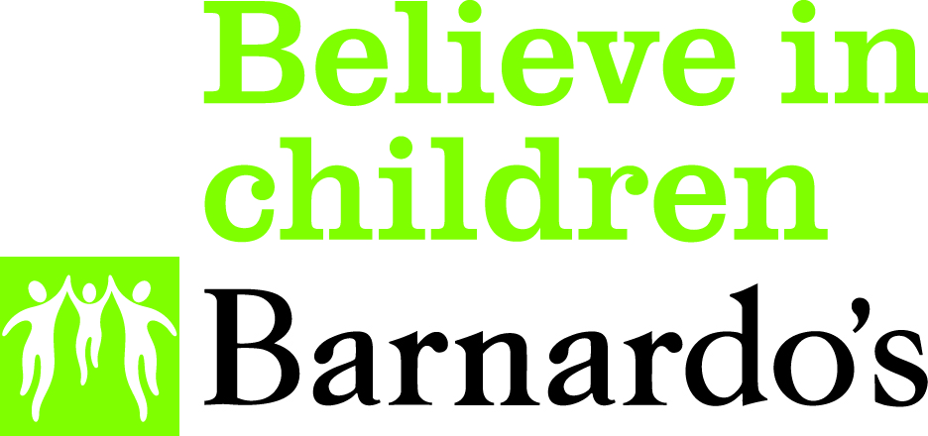

PLEASE RETURN THE COMPLETED FORM TO:

Beacon Project, Barnardo’s Black Country Roots, Blantyre House,
4 Barrack Lane, Halesowen, B63 2UX

If you have any questions regarding any section of this form or need help to complete it, please contact us on 01384 411722 Monday to Thursday between the hours of 9am and on a Friday 9am until 4:30pm

Website: www.barnardosbeacon.org.uk
Email: barnardosbeacon@barnardos.org.uk

What happens next?
- Returned and completed enquiry forms will be received by the Barnardos Beacon Team; forms received via email will receive an automated reply
- Your enquiry will be reviewed and discussed at a weekly triage meetings
- The Beacon team will aim to reply to your enquiry within 7 working days from receipt
- Our reply will provide details of support services that you will be able to access or if you prefer we can make contact with them for you

